Test Cases for Towers_of_Hanoi

Requirement to test | Test Data Input/Actions | Expected Outcomes | Actual Outcomes
- The program displays the message “Congratulations! You have successfully completed the game with the minimum number of moves” when all of the disks have been transferred to the third peg with the minimum number of moves. | Input moves as follows:  Move disk 1 to the middle peg.  Move disk 2 to the right peg.  Move disk 1 to the right peg.  Move disk 3 to the middle peg.  Move disk 1 to the left peg.  Move disk 2 to the middle peg.  Move disk 1 to the middle peg.  Move disk 4 to the right peg.  Move disk 1 to the right peg.  Move disk 2 to the left peg.  Move disk 1 to the left peg.  Move disk 3 to the right peg.  Move disk 1 to the middle peg.  Move disk 2 to the right peg.  Move disk 1 to the right peg. | 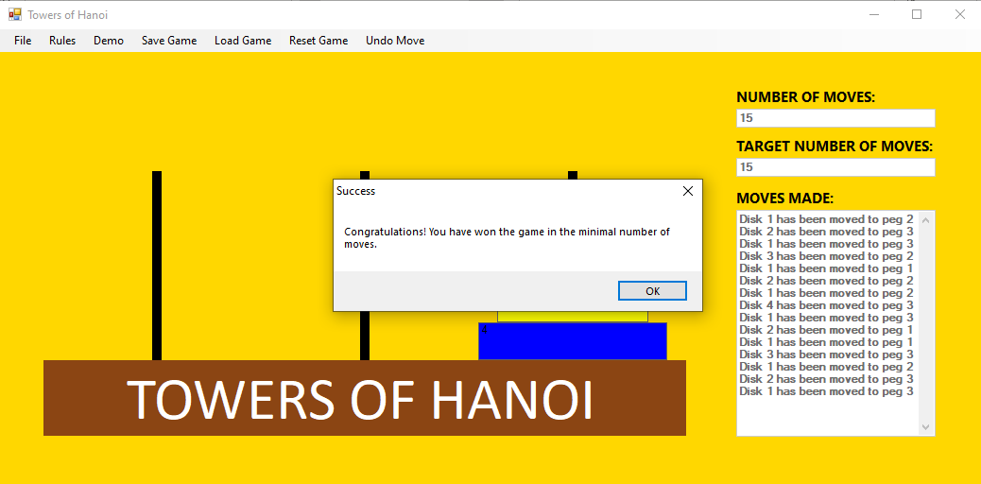 | Success
- Interface is displayed correctly when the program runs. | Step 1:  Select .  Step 2:  Enter the number “16” into the number spinner on the “Welcome to Towers of Hanoi” panel and click the “OK” button. | Step 1 Result:  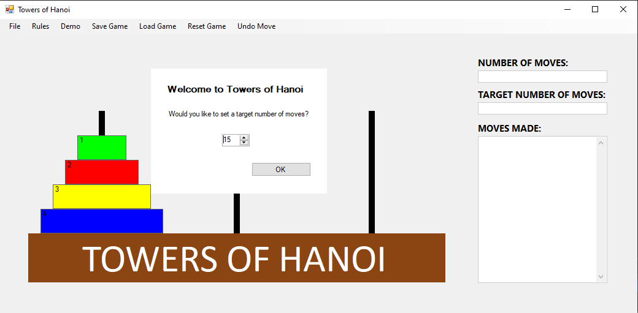  Step 2 Result:  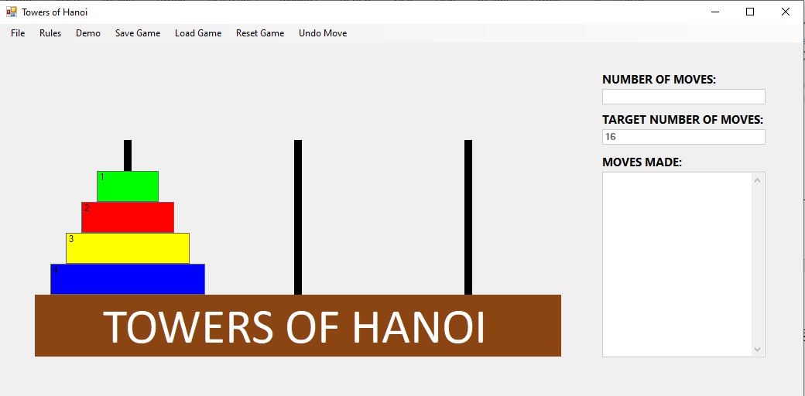 | Step 1: Success  Step 2: Success
- Valid moves are stored. | Move disk 1 to the right peg.  Move disk 2 to the middle peg. | 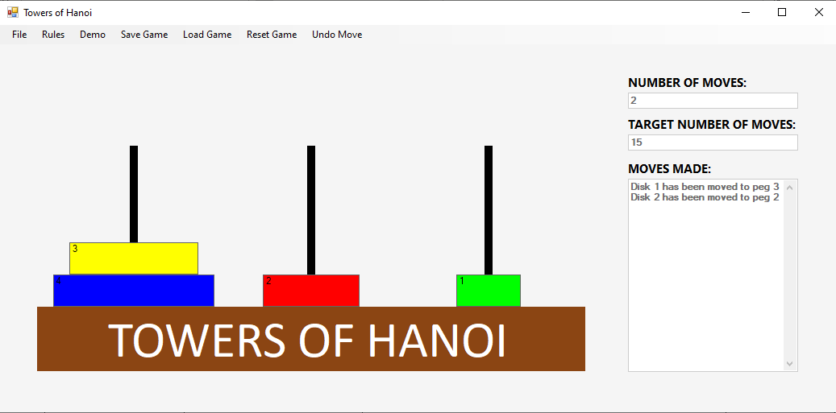 | Success

- Uses four disks and three pegs and lets the user drag and drop disks from one peg to another. | Step 1:  Move disk 1 to the middle peg.  Step 2:  Move disk 2 to the right peg.  Step 3:  Move disk 1 to the right peg.  Step 4:  Move disk 3 to the middle peg.  Step 5:  Move disk 1 to the left peg.  Step 6:  Move disk 2 to the middle peg.  Step 7:  Move disk 1 to the middle peg.  Step 8:  Move disk 4 to the right peg. | Step 1 Result:  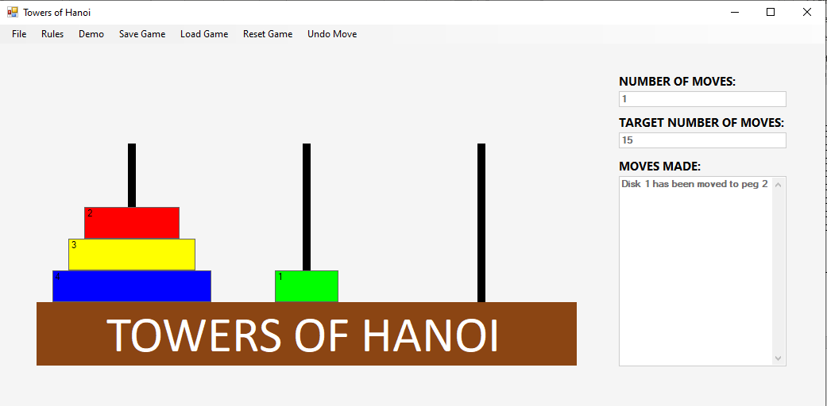  Step 2 Result:  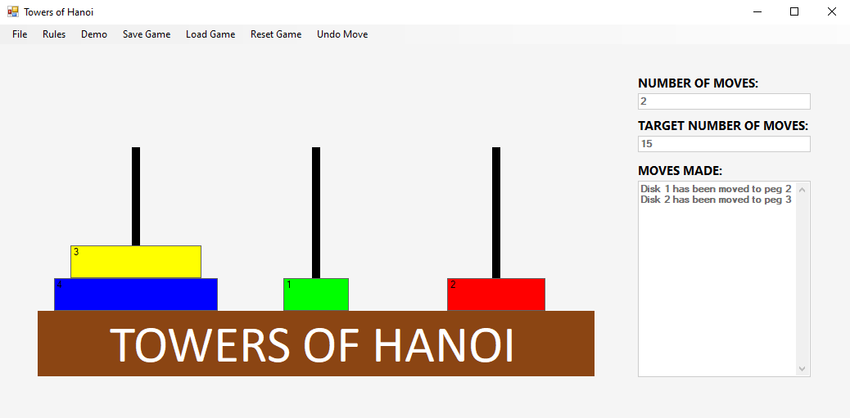  Step 3 Result:  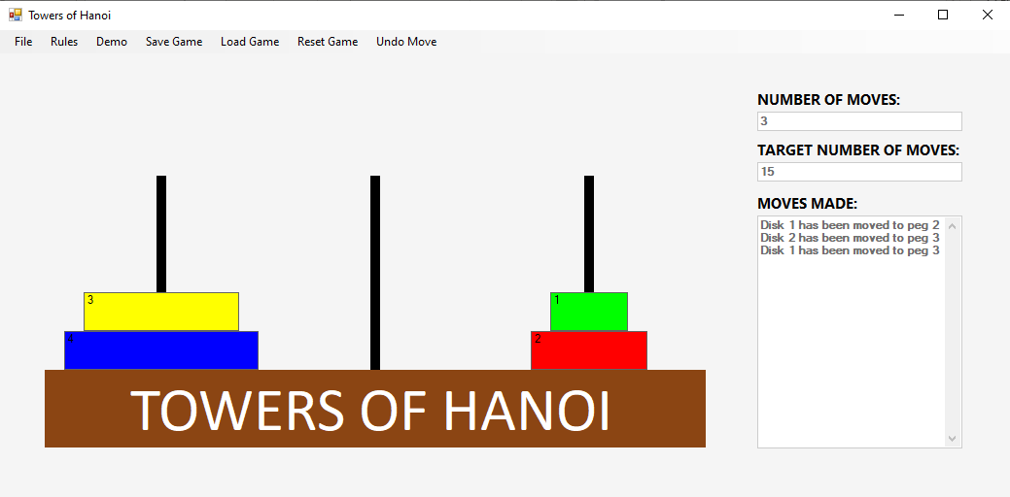  Step 4 Result:  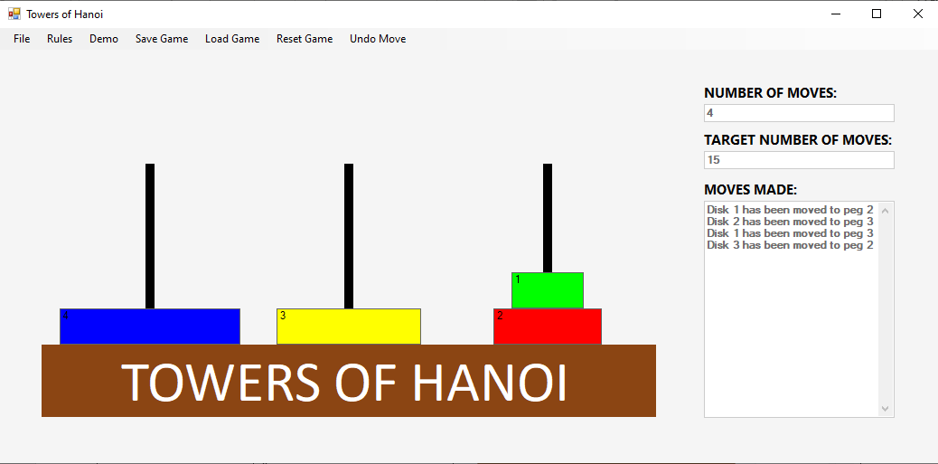  Step 5 Result:  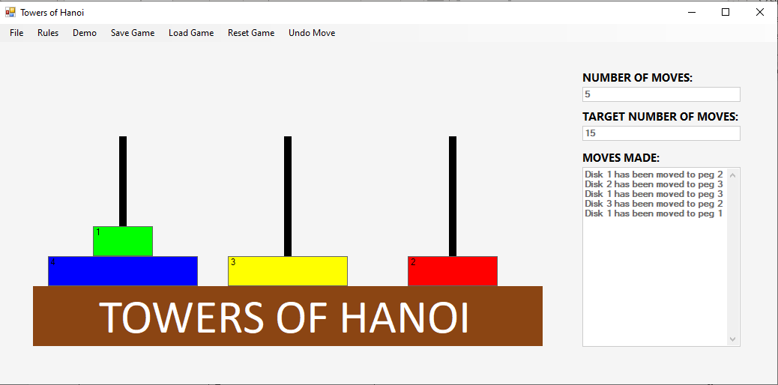  Step 6 Result:  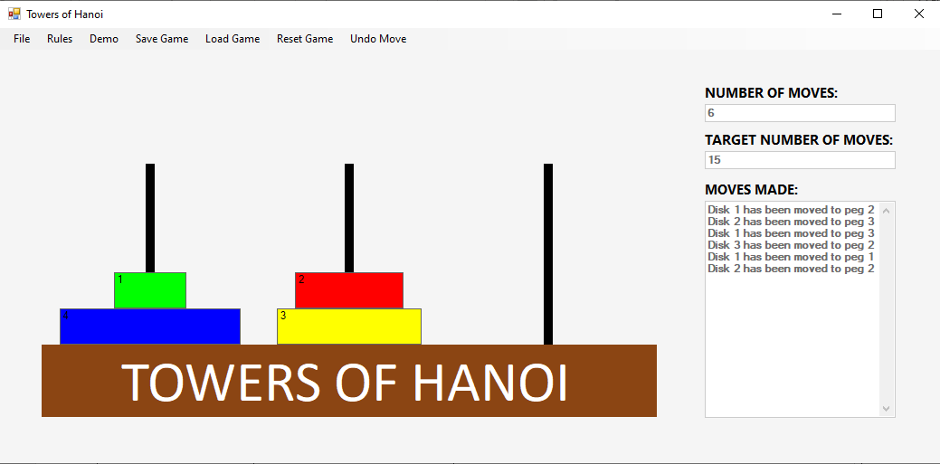  Step 7 Result:  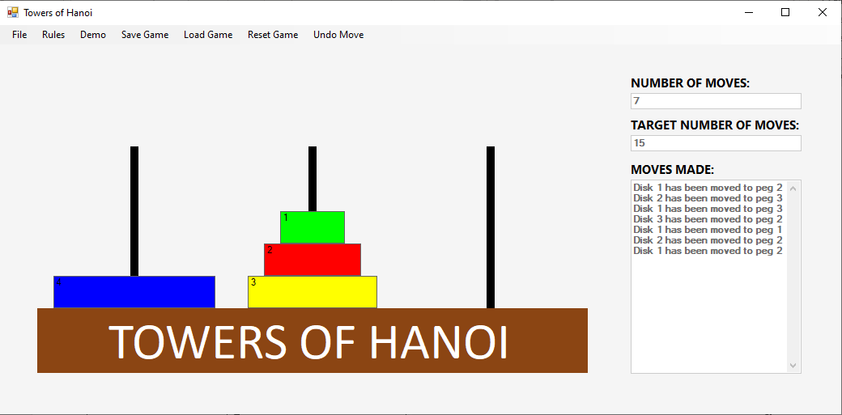  Step 8 Result:  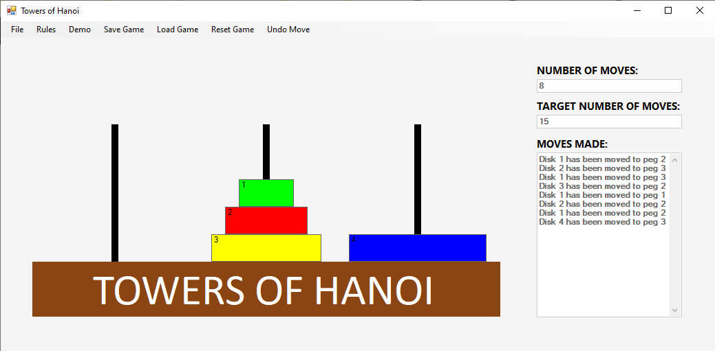 | Step 1: Success  Step 2: Success  Step 3: Success  Step 4: Success  Step 5: Success  Step 6: Success  Step 7: Success  Step 8: Success

- Keeps count of the number of moves. | Step 1:  Move disk 1 to the right peg.  Step 2:  Move disk 2 to the middle peg | Step 1 Result:  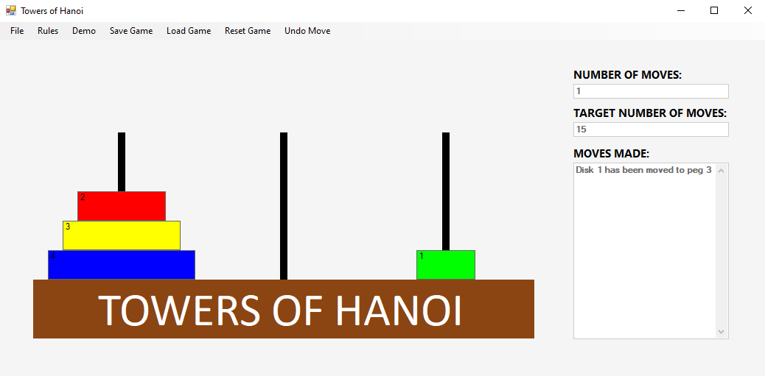  Step 2 Result:  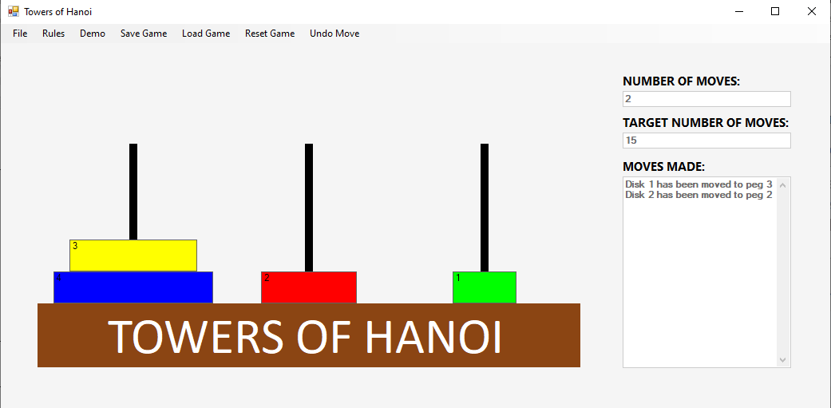 | Step 1: Success  Step 2: Success

- The program displays the message “Congratulations! You have successfully completed the game but not with the minimum number of moves” when all of the disks have been transferred to the third peg with more than the minimum number of moves. | Step 1:  Set the moves target to “15”.  Step 2:  Input moves as follows:  Move disk 1 to the middle peg.  Move disk 2 to the right peg.  Move disk 1 to the right peg.  Move disk 3 to the middle peg.  Move disk 1 to the left peg.  Move disk 2 to the middle peg.  Move disk 1 to the middle peg.  Move disk 4 to the right peg.  Move disk 1 to the right peg.  Move disk 2 to the left peg.  Move disk 1 to the left peg.  Move disk 3 to the right peg.  Move disk 1 to the middle peg.  Move disk 2 to the right peg.  Move disk 1 to the left peg.  Move disk 1 to the right peg. | Step 1:  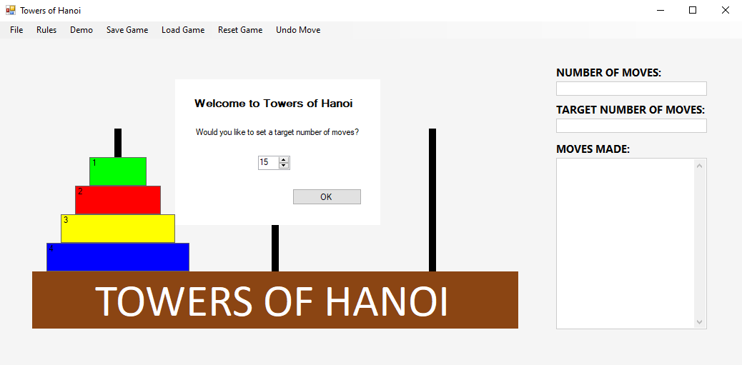  Step 2 Result:  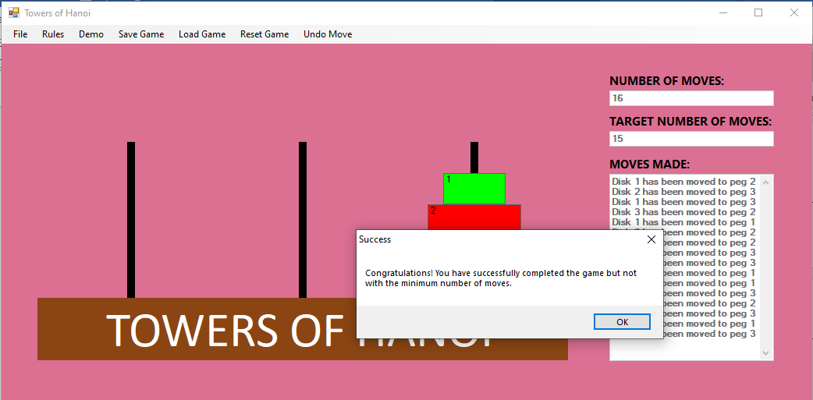 | Step 1: Success  Step 2: Success

- Display the game rules. | Select “Rules” on the menu. | Result:  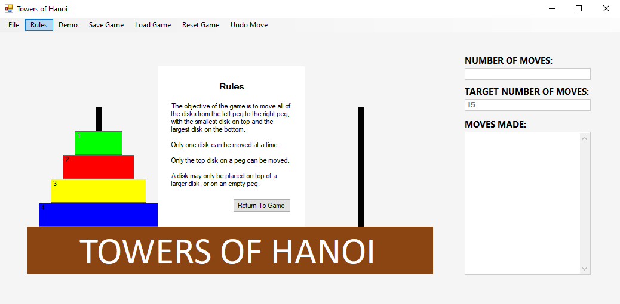 | Success
- Try moving more than one disk at a time | Attempt to select disk 1 and 2 on the left peg by clicking on the disks and pressing the shift key at the same time. | Result:  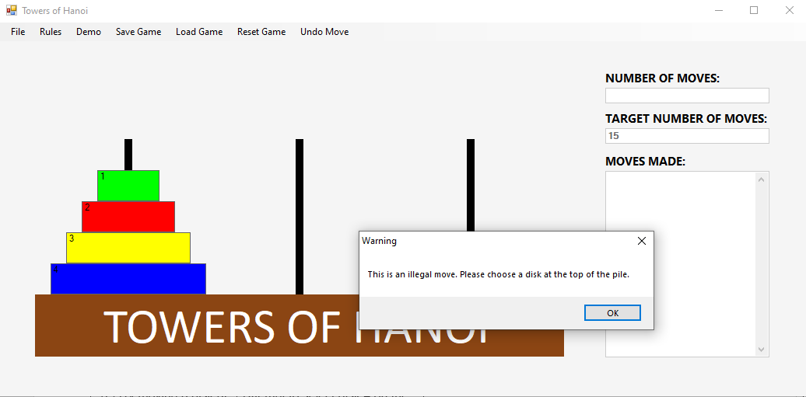 | Success
- Try moving a disk at the bottom of a pile. | Attempt to select disk 4 on the left peg. | 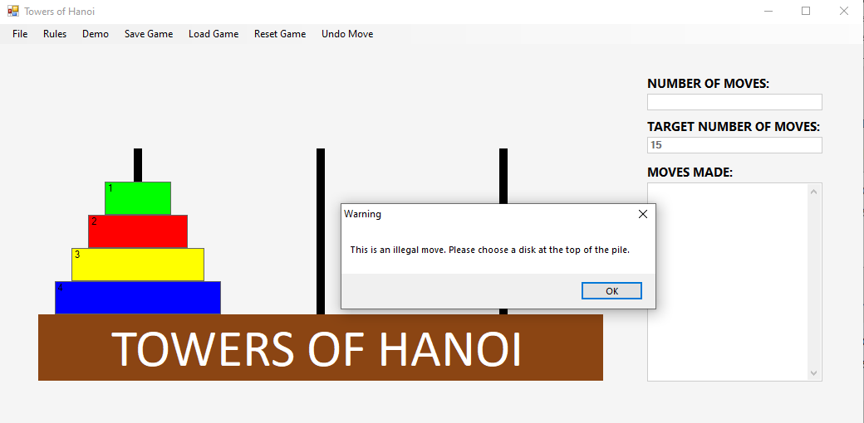 | Success
- Try moving a disk second from top of a pile. | Attempt to select disk 2 on the left peg. |  | Success

- Try putting a larger disk on top of a smaller disk. | Step 1  Move disk 1 to the middle peg.  Step 2:  Try to move disk 2 to the middle peg. | Step 1 Result:  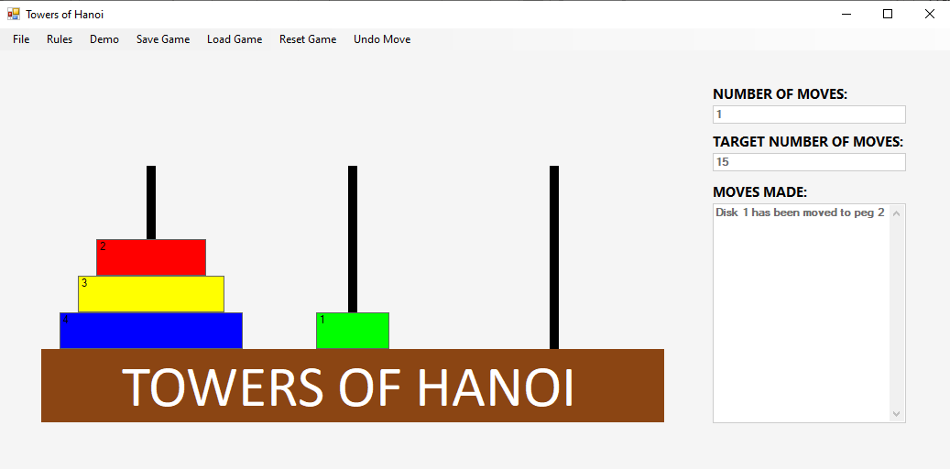  Step 2 Result:  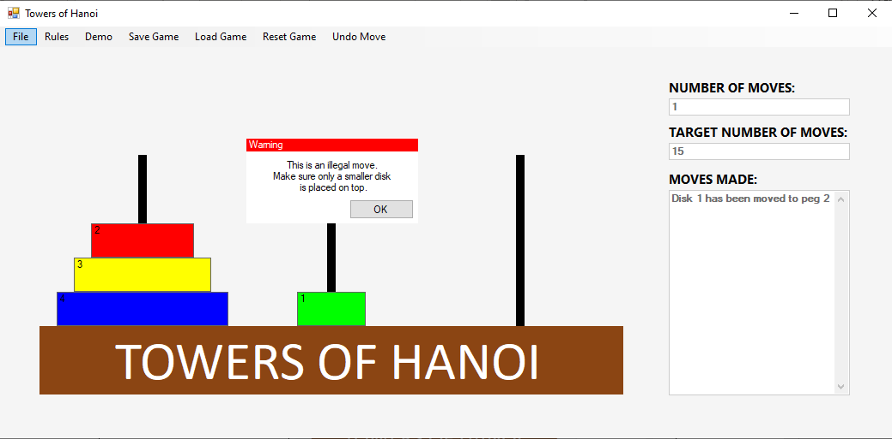 | Step 1: Success  Step 2: Success

- Begin a new game after a game has been started | Step 1:  Move disk 1 to the middle peg.  Move disk 2 to the right peg.  Step 2:  Click “Reset Game” on the menu bar. | Step 1 Result:  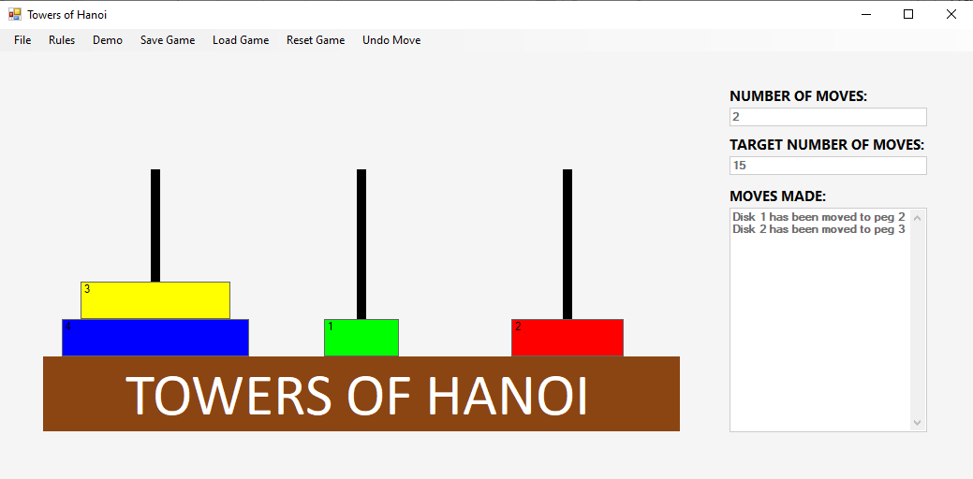  Step 2 Result:  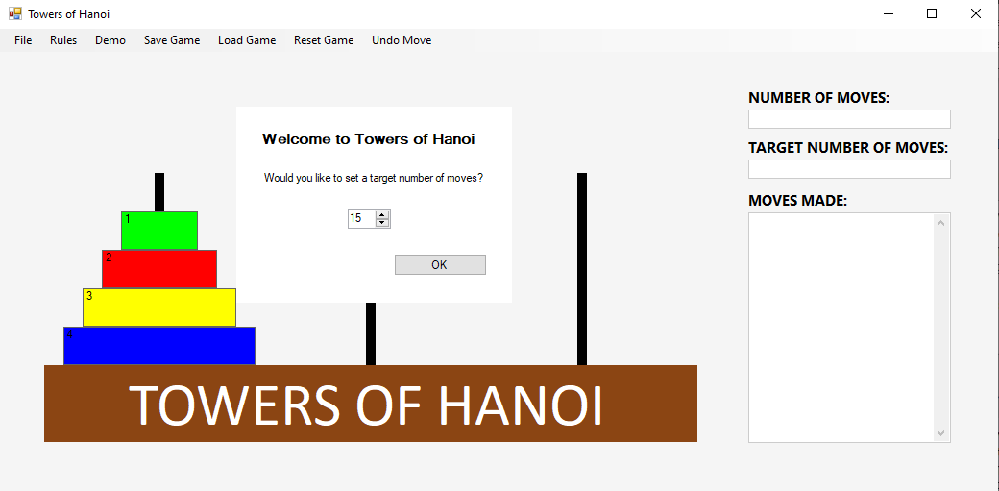 | Step 1: Success  Step 2: Success

- Number of moves set to zero | Step 1:  Move disk 1 to the middle peg.  Move disk 2 to the right peg.  Step 2:  Click “Reset Game” on the menu bar. | Step 1 Result:  Step 2 Result: | Step 1: Success  Step 2: Success

- Disks moved back to starting positions | Step 1:  Move disk 1 to the middle peg.  Move disk 2 to the right peg.  Step 2:  Click “Reset Game” on the menu bar. | Step 1 Result:  Step 2 Result: | Step 1: Success  Step 2: Success

- Save an incomplete game. | Step 1:  Move disk 1 to the middle peg.  Move disk 2 to the right page.  Click “Save Game” on the menu bar.  Step 2:  Select “Save Game” from the menu and write filename as “saveIncompleteTest.txt”. Select Save.  Step 3:  Check the location in your file explorer. | Step 1 Result:  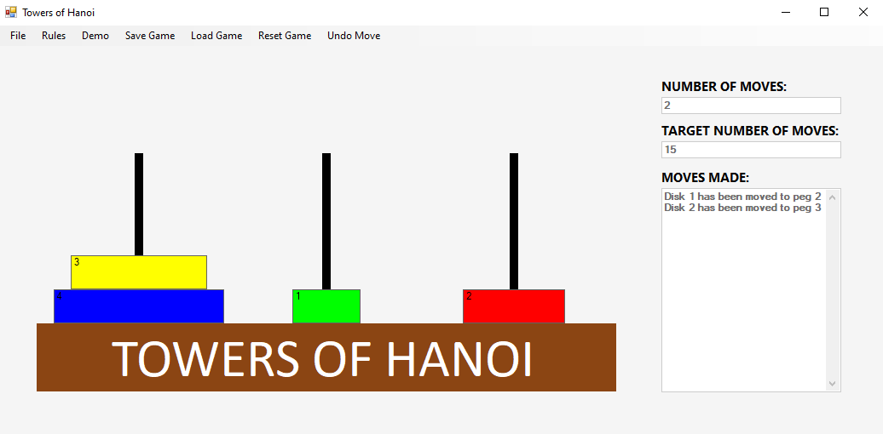  Step 2 Result:  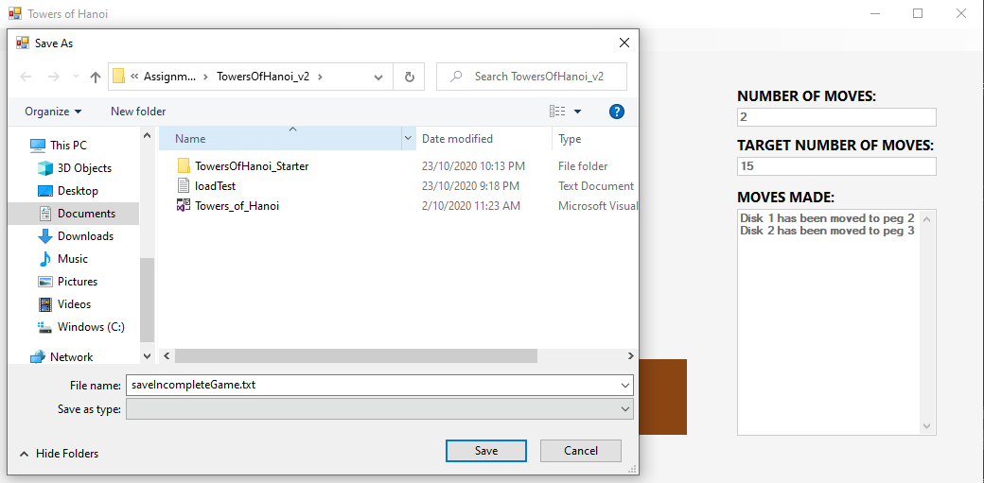  Step 3 Result  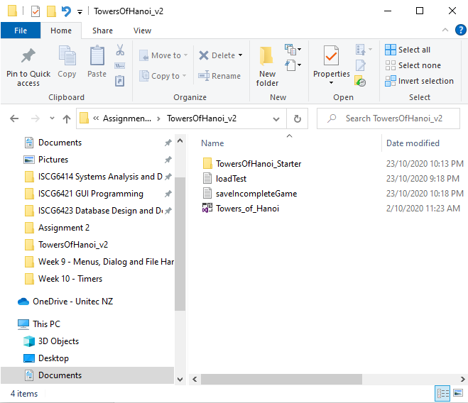 | Step 1: Success  Step 2: Success  Step 3: Success
- Load an incomplete stored game and finish it. | Step 1:  Click “Load Game” on the menu bar.  Step 2:  Select “loadTest.txt” file. | Step 1 Result:  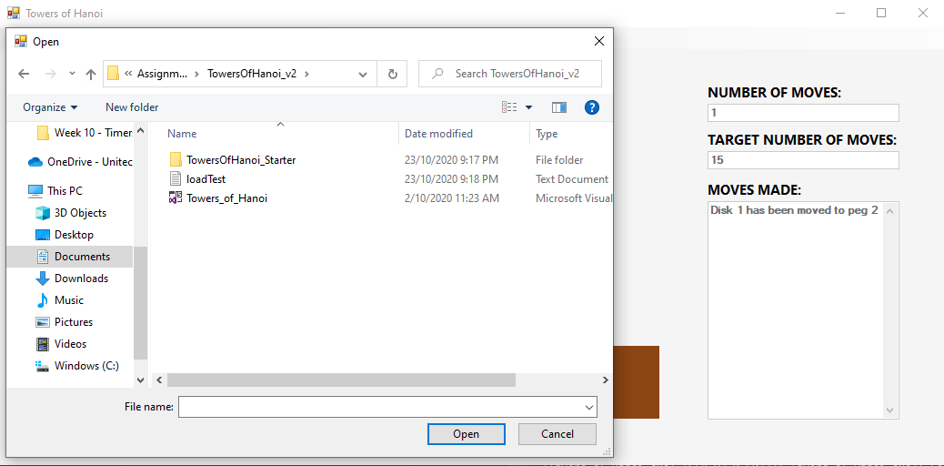  Step 2 Result:  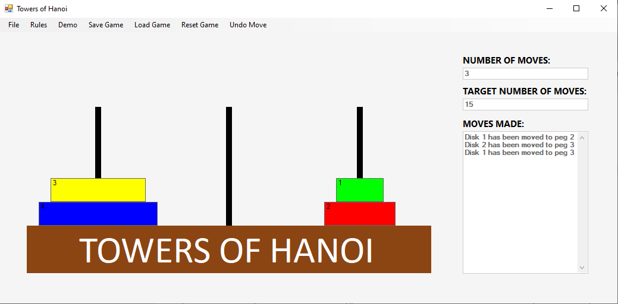 | Step 1: Success  Step 2: Success
- Play a completed game from a list of stored moves using animation controlled by a timer. | Select “Demo” from the menu bar. | Result:  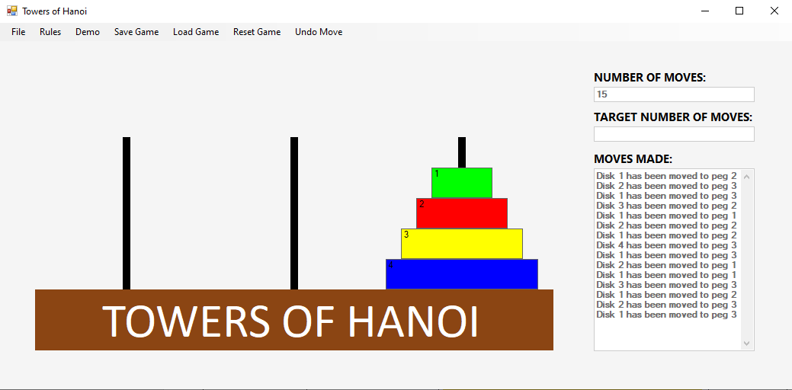 | Partially successful.  Animation runs, but not at a slow enough rate.

